CS1555 Assignment 7

Qutestion1:

(a)

1) Insert 2, 3, 5, 7, 11, 17, 9, 13, 4. 13 mod 4 = 1, put into overflow bucket.

BSplit

BLast

1

0

2

3

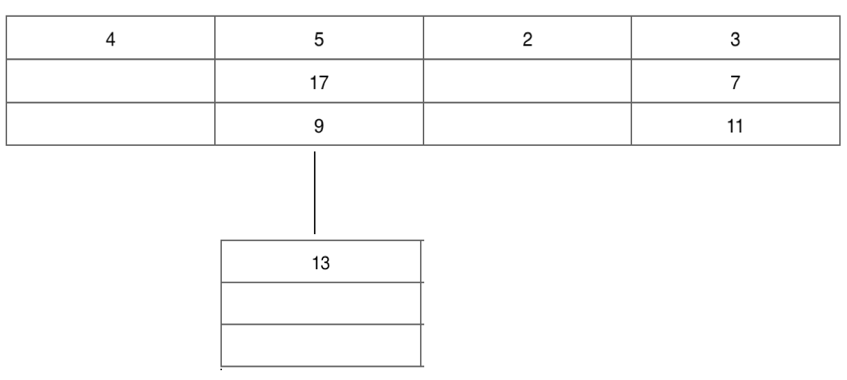

2) Insert 19, 19 mod 4 = conflict with bucket[3]. Split bucket[0], add bucket[4] 4 mod 8 = 4, put 4 into bucket[4], increment BSplit. 19 still in conflict with bucket 3.

BSplit

BLast

0

2

3

4

1

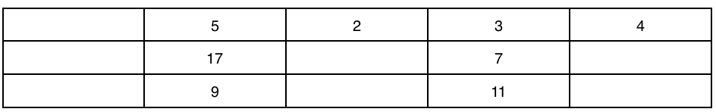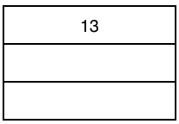

3) Split bucket[1], add bucket[5], {5,13} mod 8 = 5, put 5 and 13 into bucket[5]. Overflow bucket for bucket[1] is freed. New overflow bucket is added due to 2 consecutive splits for 19 in conflict to bucket[3]. Put 19 into overflow bucket for bucket[3].

BSplit

Blast

0

1

2

3

4

5

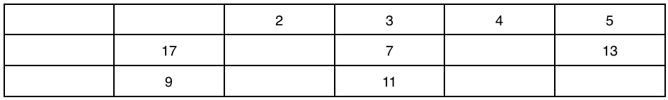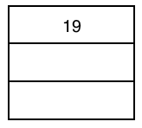

4) Insert 20, 29, 31, 25, 23. 20 mod 4 = 0, bucket[0] has split, 20 mod 8 = 4, and so on.

Blast

BSplit

4

5

3

1

0

2

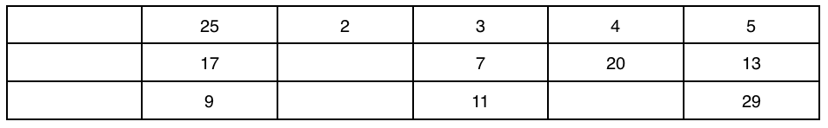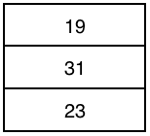

(b)

5) Delete 7, 23, 31

Blast

BSplit

1

3

2

4

0

5

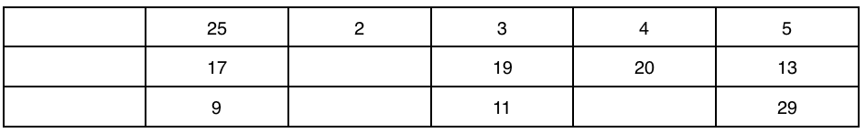

|  |  |  |  |  |  |
| --- | --- | --- | --- | --- | --- |
|  | 25 | 2 | 3 | 4 | 5 |
|  | 17 |  | 19 | 20 | 13 |
|  | 9 |  | 11 |  | 29 |

|  |
| --- |
| 19 |
| 31 |
| 23 |

